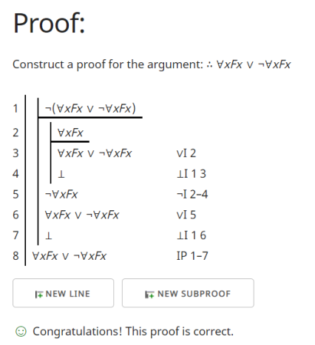1.

2.

3.

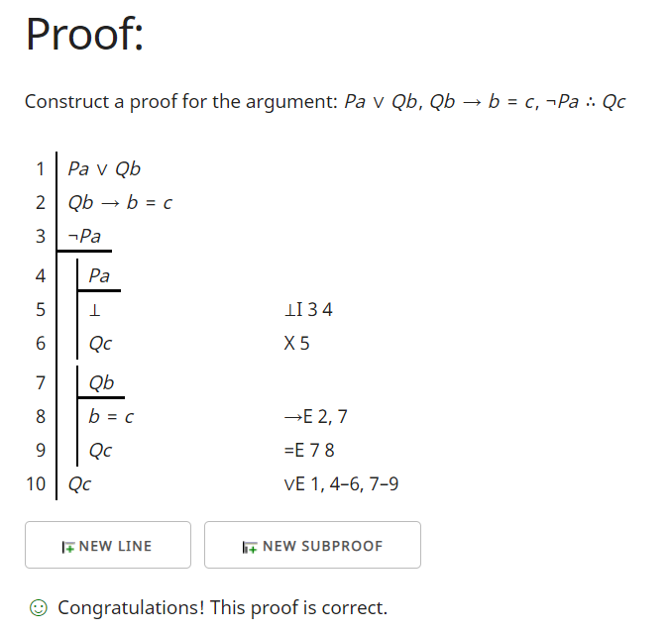4.

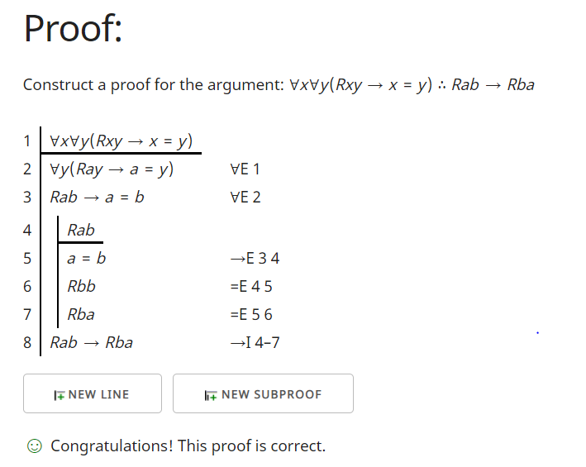5.